Star Traveller (or Us Against the Star)

Equipment: playing cards 1 through 6 (24 cards total), 1 die (1-6), pencil and paper

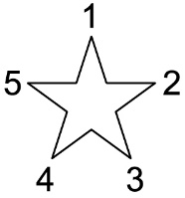
Object: the object is for players to work together to take away all the cards before crossing off all 5 points on the star
- On paper, draw a 5-pointed star. Label the points 1-5.
- Lay the cards out, face up, in 6 rows, 4 cards in each row.
- Place one cube at the bottom of each column.
- Roll the die. This is the sum you will try to make using only the cards with cubes
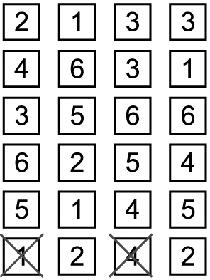
- You may use addition, subtraction or a combination of operations to make the target sum.
- You can make the target sum with 1, 2 or 3 cards.
Example on right: Player rolls 5. They can take 1 and 4 (4+1) or 2, 2 and 1 (2+2+1) or
4, 2 and 1 (4+2-1).

- Remove the used cards. Transfer the cubes to the new bottom card of each column.
- If a card or combination of cards cannot be found to equal the target number, cross out
one point on your star.
= one cube

PLAY CONTINUES UNTIL ALL CARDS ARE REMOVED OR ALL POINTS OF THE STAR ARE CROSSED OFF!

