Secret Pairs - addition
Materials: deck of cards (only use 1 through 5) vary cards used to change difficulty
2 Players
Each player is dealt 4 cards. Players then arrange their cards into 2 pairs, face down on a dry erase board in front of them, keeping these pairs secret from the other player. Write the sum next to each face-down pair.
The other player looks at a sum and tries to guess which two numbers are on the hidden cards to produce the given sum. (ex. your secret pair is 4 and 3 you wrote down 7. If your partner guesses “4 and 3” they get to keep the two cards. If they guess “6 and 1”, you get to keep the cards).
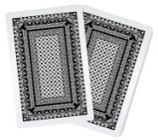
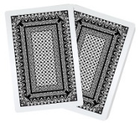
Players then swap roles. Once both have guessed each other’s pairs, deal out 4 more cards to each player and repeat. Continue until all cards are gone. Winner is the player with the most cards at the end of the game.
2
5
4
10

Variations:
Easier – Use fewer cards (0-3, 1-4, etc.)
Harder – Use more cards (0-8, 1-9, etc.)

