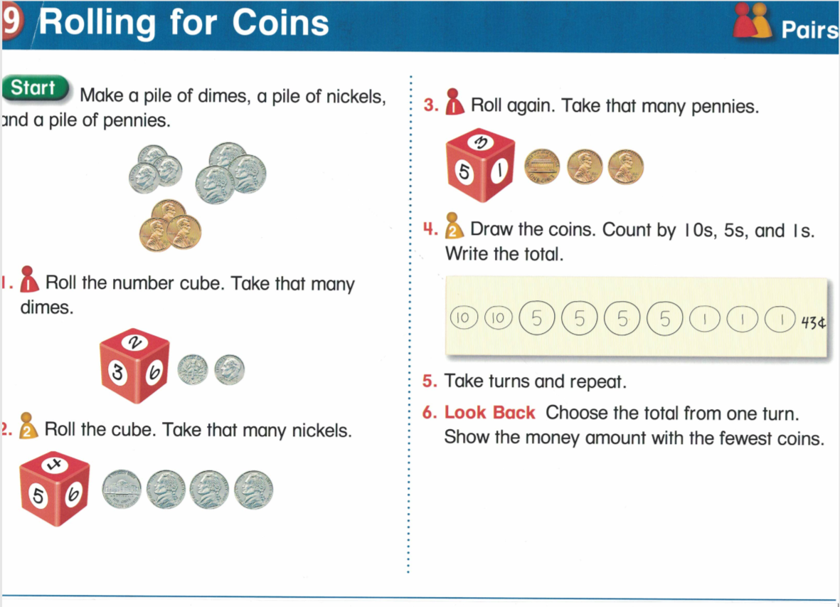

Variations:
Easier: Use only dimes and pennies, nickels and pennies, or dimes and nickels
Easier: Use a 1-4 die
Harder: Use and 8-, 9-, or 12-sided die
Harder: Add quarters

