Make a Pattern

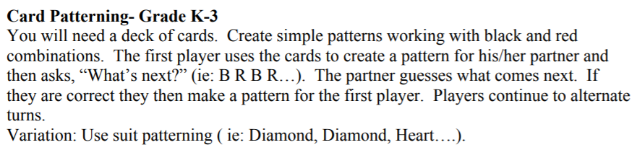
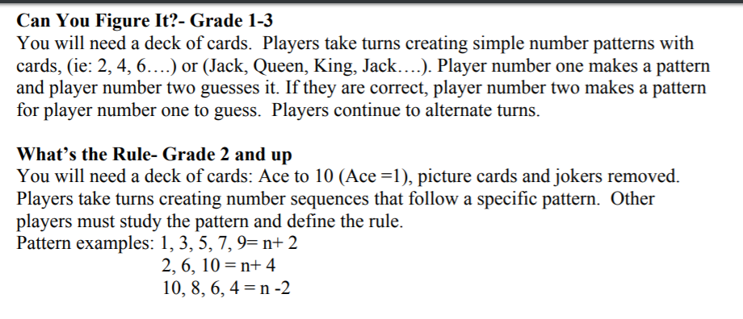

Variations:
Use a 0-100 deck of cards (in Math Room)

