I Spy Sums

Players: 2
Materials: Deck of cards, remove the 0’s
How to Play:
Deal out the entire deck in a 13 x 4 array. One player challenges the other to find 2 CARDS NEXT TO EACH OTHER, EITHER VERTICALLY OR HORIZONTALLY, that add to a number by saying, “I spy two cards with a sum of ___.”

The other player looks for 2 cards next to each other with that sum and removes them. Players swap roles. As large gaps appear, the size of the array can be reduced to eliminate gaps.
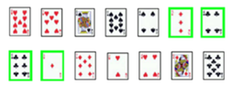

Variations:
Easier: Use fewer cards (1-10 or 1-6).

