Family of 3
Materials: 1-10 cards in 4 colors

- Deal out 9 cards face up in a 3x3 array.
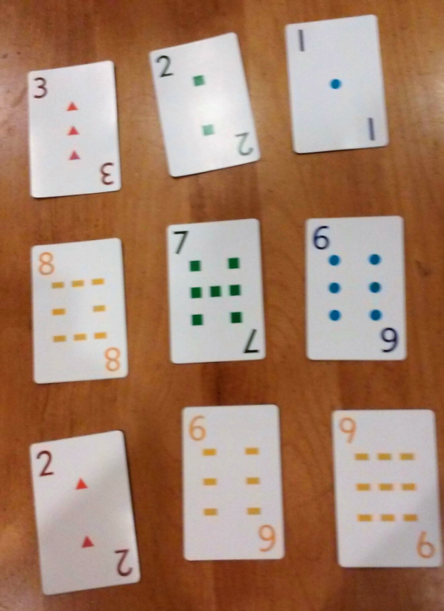
- The goal is to find a SET.

A SET consists of:
  - 3 cards
  - 2 cards add up to the 3rd
  - All 3 different colors

Example: blue 1 + yellow 6 = green 7
(or red 2 + blue 6 = yellow 8)

- You can play taking turns or whoever
spots a set puts both thumbs up on
the table and says, “I found one!”

- If correct, player gets to take that set and 3 more cards are added.
- If no set is found, add an extra card and continue until a SET is found.
- Game ends when all cards have been dealt out and no more SETS can be found.

Variation:
- Take color out of the set, just find 2 cards that add up to a third card.
- For younger students, find 3 numbers in sequence, with or without the color. Example above: blue 6, green 7, yellow 8 or blue 1, green 2, red 3

