“Crazy 7 Fans”
Materials: 0-13 card deck
Deal out 5 cards to each player. The player to the dealer’s left begins by playing a 7 of any suit. If that player does not have a 7, then the play passes left to the first player who does.
After that, on your turn you may lay down another 7 or play on the cards that are already down. If you cannot play a card, take one from the pile. If you can play the new card, lay it down on the fans. If you cannot play the new card, keep it with your hand.
Once a 7 is played in any suit, the 6 and the 8 of that suit may be played on either side of it, forming the fan. Then the 5 through 0 can go on the 6 in counting-down order, and the 9 through 13 can go on the 8, counting up. You can arrange these cards to overlap each other so the cards below are visible, or you can square up the stacks so only the top card is seen.
The first player to run out of cards wins the game.
If you want to keep score, count the cards remaining in your hand after one player goes out. After everyone has had a turn as dealer, whoever has the lowest total score is the champion.
Variations:
Easier: Use only two suits instetad of all 4 suits.
Easier: Instead of 7’s, put down 0 to start and count up only.
Easier: Instead of 7’s, put down 13 to start and count down only.
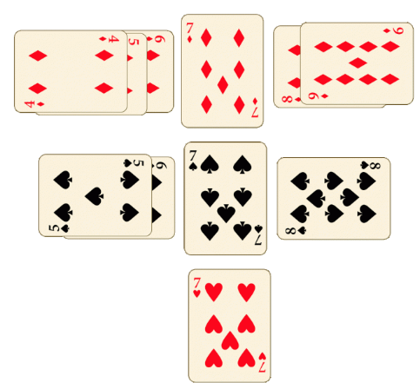
Harder: Use all 4 suits.

